**TaxBreeze Architecture**

The primary purpose of the TaxBreeze Web Portal is to capture and funnel in all information related to an applicant’s tax portfolio. Along with user information, it also provides interfaces to upload documentary evidence related to tax filings. All sensitive information is encrypted including uploaded documents. The tax processing happens at the PWC backend systems. The results from the tax processing are transmitted back to the portal using web services layer provided to PWC backend systems.

PwC TaxBreeze is modelled after the MVC4 Architectural pattern which divides the application into Models, Views and Controllers to reduce complexity. The application has a web front end developed in ASP.net & JQuery and utilizes an MSSQL server in the backend. It also provides a service layer that interacts with PWC backend systems. The application is deployed and hosted on Azure. The application has been thoroughly tested to uncover security vulnerabilities. It uses DES3 encryption for passwords and sensitive information and deployed on a Secure Server with SSL/TSL. All configuration files deployed on the server related to the application is devoid of credentials and other sensitive information as they are stored on the Azure Server Store. It makes use of a well-known payment gateway for financial transactions. The application also boasts a Chabot to provide real time answers to questions related to taxes. The application also uses SendGrid for emails and Twilio for SMS messages (Push Notifications)

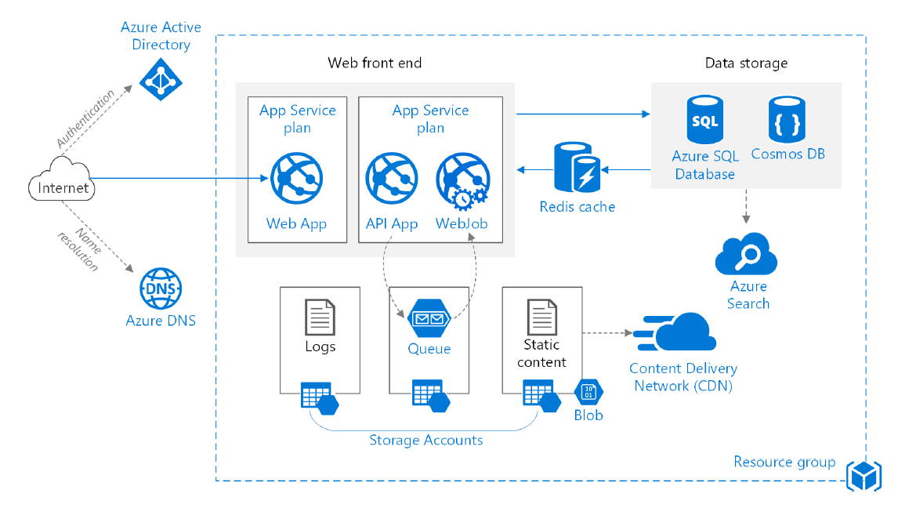

The diagram above depicts the application deployment plan of TaxBreeze in Azure. It uses proven practices for scalability and performance. The Web application and Web API are deployed as separate apps. The design allows them to run containers so that they can scaled independently. The SQL database supports sharding so that it can be scaled out horizontally. The application has built in support for CORS and the database supports transparent data encryption